TASK 12 – Re-evaluate and Adapt the Design 8 MarksBloom’s Level: K5 – Evaluate
Changed Requirement
The university introduces two new vehicle categories – e-bikes (charged a flat fee) and delivery vans (charged at double the car rate during 9 AM – 5 PM). Visitors may now buy a one-day pass. The facility is extended from 3 to 5 floors with a different number of slots on each floor.
Re-evaluate your original design in response to these changed requirements. You may RETAIN → MODIFY → or REDESIGN your original solution.
A. Impact Analysis – 2 Marks
Discuss:
• What has changed from the original problem • Which of your classes, methods and data structures are affected • Why a different number of slots on each floor affects your array design • Which classes, if any, would have to be modified rather than extended
Evidence Expected
A clear analysis of how the changed requirements affect the original design. B. Evaluation of the Original Design – 2 Marks
Evaluate whether your original design remains appropriate. Discuss:
• Whether new vehicle types can be added only by writing new subclasses • Whether the pricing rules are spread across many classes or kept in one place • Whether the existing tested classes can remain unchanged
Evidence Expected
A technically supported evaluation of the original design under the new requirements. C. Adaptation or Redesign – 2 Marks
Decide whether to retain, modify or redesign the design. If you modify or redesign it: • Describe the revised class structure (for example: a jagged array for floors, a Pass interface, a PricingRule abstraction)
• Explain what has changed
• Implement the new vehicle categories and the one-day pass
If you retain the original design, provide sufficient technical justification for why no redesign is necessary.
Evidence Expected
An appropriate design response with clear object-oriented reasoning and working code. D. Evidence-Based Defence – 2 Marks
Defend your final design decision using:
• The number of existing classes that had to change
• The ease of adding a further vehicle type in future
• Test results for the new categories
• Relevant trade-offs
Your final decision must follow logically from your analysis.
Evidence Expected
A well-supported final design decision integrating object-oriented principles, test evidence and the changed requirements.
MARK DISTRIBUTION
Task | Bloom’s  Level | Marks
Task 1 – Problem Analysis & Objects | K4 – Analyse | 4
Task 2 – Data Representation | K4 – Analyse | 3
Task 3 – Control Logic & Pseudocode | K4 – Analyse | 4
Task 4 – Classes, Objects & Constructors | K4 – Analyse | 4
Task 5 – static Members & Object Life Cycle | K4 – Analyse | 3
Task 6 – Inheritance Hierarchy | K4 – Analyse | 4
Task 7 – Method Overriding | K4 – Analyse | 4
Task 8 – Polymorphism | K4 – Analyse | 4
Task 9 – Abstraction | K4 – Analyse | 4
Task 10 – Packages & Encapsulation | K4 – Analyse | 3
Task 11 – Implementation, Testing & Defence | K5 – Evaluate | 5
Subtotal |  | 42
Task 12 – Day-4 Design Challenge | K5 – Evaluate | 8
TOTAL |  | 50

Submission Requirements
• GitHub repository link (mandatory) containing the executed code for every task, including every completed “Complete the Code” program, with input files, output screenshots and a README.md.
• Your assignment report containing the required evidence for Tasks 1–12, including UMLdiagrams, pseudocode, test tables and complexity analyses.
Assessment Verification
Students may be asked to explain, execute or modify any part of their code during a brief verification discussion/viva. The student should be able to explain and defend the work submitted as their own.
Answer:
New requirement | What you need to change
E-bike | Add an EBike vehicle class
Delivery van | Add a DeliveryVan class and special fee calculation
One-day visitor pass | Add pass validity and expiry information
Five floors | Use a jagged 2D array with five different row sizes

A. E-bike
An e-bike should have its own flat parking fee, regardless of parking duration.

B. Delivery van
A delivery van must pay double the normal car rate when its parking falls within the specified 9 AM–5 PM period.

C. Visitor one-day pass
A visitor with a valid one-day pass should be charged zero parking fee during the pass validity period.

D. Five floors with different slot counts
Example:
int[] slotsPerFloor = {5, 8, 6, 10, 4};
This means:
- Floor 0: 5 slots
- Floor 1: 8 slots
- Floor 2: 6 slots
- Floor 3: 10 slots
- Floor 4: 4 slots
This is called a jagged array.

3. Java program
Pricing assumptions for this demonstration:
- E-bike: flat fee of Rs 25 per parking session.
- Car: Rs 30 per started hour.
- Delivery van: Rs 60 per hour during 9 AM–5 PM and Rs 30 per hour outside that period, calculated proportionally by minutes.
- Visitor one-day pass: free parking until 24 hours after purchase.

import java.util.HashMap;
import java.time.LocalDateTime;
import java.time.LocalDate;
import java.time.Duration;

// Parent class
abstract class Vehicle {
String regNo;
String userType;
boolean oneDayPass;
LocalDateTime passExpiry;

Vehicle(String regNo, String userType, boolean oneDayPass,
LocalDateTime entryTime) {
this.regNo = regNo;
this.userType = userType;
this.oneDayPass = oneDayPass;

if (oneDayPass && userType.equals("Visitor")) {
passExpiry = entryTime.plusDays(1);
}
}

abstract double calculateFee(LocalDateTime entry,
LocalDateTime exit);
}

// Car class
class Car extends Vehicle {

Car(String regNo, String userType, boolean pass,
LocalDateTime entry) {
super(regNo, userType, pass, entry);
}

@Override
double calculateFee(LocalDateTime entry, LocalDateTime exit) {
long minutes = Duration.between(entry, exit).toMinutes();
long hours = (minutes + 59) / 60;
return hours * 30.0;
}
}

// New category: E-bike
class EBike extends Vehicle {

EBike(String regNo, String userType, boolean pass,
LocalDateTime entry) {
super(regNo, userType, pass, entry);
}

@Override
double calculateFee(LocalDateTime entry, LocalDateTime exit) {
return 25.0; // Flat fee
}
}

// New category: Delivery van
class DeliveryVan extends Vehicle {

DeliveryVan(String regNo, String userType, boolean pass,
LocalDateTime entry) {
super(regNo, userType, pass, entry);
}

@Override
double calculateFee(LocalDateTime entry, LocalDateTime exit) {

long totalMinutes =
Duration.between(entry, exit).toMinutes();

long daytimeMinutes = 0;

// Find parking time that overlaps 9 AM to 5 PM
LocalDate date = entry.toLocalDate();

while (!date.isAfter(exit.toLocalDate())) {

LocalDateTime dayStart = date.atTime(9, 0);
LocalDateTime dayEnd = date.atTime(17, 0);

LocalDateTime start =
entry.isAfter(dayStart) ? entry : dayStart;

LocalDateTime end =
exit.isBefore(dayEnd) ? exit : dayEnd;

if (end.isAfter(start)) {
daytimeMinutes +=
Duration.between(start, end).toMinutes();
}

date = date.plusDays(1);
}

long outsideMinutes = totalMinutes - daytimeMinutes;

// Double car rate during daytime = Rs 60/hour
// Normal car rate outside daytime = Rs 30/hour
return (daytimeMinutes * 60.0 / 60)
+ (outsideMinutes * 30.0 / 60);
}
}

// Parking ticket
class ParkingTicket {
static int counter = 2000;

String ticketNo;
Vehicle vehicle;
int floor;
int slot;
LocalDateTime entryTime;

ParkingTicket(Vehicle vehicle, int floor, int slot,
LocalDateTime entryTime) {
counter++;
ticketNo = "T" + counter;
this.vehicle = vehicle;
this.floor = floor;
this.slot = slot;
this.entryTime = entryTime;
}
}

// Parking facility
class ParkingFacility {

private ParkingTicket[][] slots;
private HashMap<String, ParkingTicket> activeTickets;

ParkingFacility(int[] slotsPerFloor) {

slots = new ParkingTicket[slotsPerFloor.length][];

for (int i = 0; i < slotsPerFloor.length; i++) {
slots[i] = new ParkingTicket[slotsPerFloor[i]];
}

activeTickets = new HashMap<>();
}

// Allocate a slot and issue a ticket
void enterVehicle(Vehicle vehicle, LocalDateTime entryTime) {

if (activeTickets.containsKey(vehicle.regNo)) {
System.out.println("Duplicate registration rejected.");
return;
}

for (int f = 0; f < slots.length; f++) {
for (int s = 0; s < slots[f].length; s++) {

if (slots[f][s] == null) {

ParkingTicket ticket =
new ParkingTicket(vehicle, f, s, entryTime);

slots[f][s] = ticket;
activeTickets.put(vehicle.regNo, ticket);

System.out.println("Vehicle parked: "
+ vehicle.regNo);
System.out.println("Ticket: "
+ ticket.ticketNo);
System.out.println("Floor: " + f
+ ", Slot: " + s);

return;
}
}
}

System.out.println("Parking Full.");
}

// Exit vehicle and calculate fee
void exitVehicle(String regNo, LocalDateTime exitTime) {

ParkingTicket ticket = activeTickets.get(regNo);

if (ticket == null) {
System.out.println("Ticket not found.");
return;
}

if (exitTime.isBefore(ticket.entryTime)) {
System.out.println("Invalid exit time.");
return;
}

Vehicle vehicle = ticket.vehicle;
double fee;

// Valid visitor one-day pass
if (vehicle.userType.equals("Visitor")
&& vehicle.oneDayPass
&& !exitTime.isAfter(vehicle.passExpiry)) {
fee = 0;
} else {
fee = vehicle.calculateFee(ticket.entryTime, exitTime);
}

slots[ticket.floor][ticket.slot] = null;
activeTickets.remove(regNo);

System.out.println("Vehicle exited: " + regNo);
System.out.println("Parking Fee: Rs " + fee);
System.out.println("--------------------");
}
}

// Main class
public class Main {

public static void main(String[] args) {

// Five floors with different slot counts
ParkingFacility parking =
new ParkingFacility(new int[]{1, 2, 1, 2, 1});

System.out.println("CAMPUS SMART PARKING - TASK 12");
System.out.println("--------------------");

// Test 1: E-bike
LocalDateTime eBikeEntry =
LocalDateTime.of(2026, 11, 7, 11, 0);

EBike ebike = new EBike(
"TN01EB1234", "Visitor", false, eBikeEntry);

parking.enterVehicle(ebike, eBikeEntry);

// Test 2: Delivery van from 8 AM to 10 AM
LocalDateTime vanEntry =
LocalDateTime.of(2026, 11, 7, 8, 0);

DeliveryVan van = new DeliveryVan(
"TN02DV5678", "Visitor", false, vanEntry);

parking.enterVehicle(van, vanEntry);

// Test 3: Visitor with one-day pass
LocalDateTime passEntry =
LocalDateTime.of(2026, 11, 7, 12, 0);

Car visitor = new Car(
"TN03VC9012", "Visitor", true, passEntry);

parking.enterVehicle(visitor, passEntry);

// Test 4: Normal car
LocalDateTime carEntry =
LocalDateTime.of(2026, 11, 7, 15, 0);

Car car = new Car(
"TN04CA3456", "Visitor", false, carEntry);

parking.enterVehicle(car, carEntry);

System.out.println("--------------------");
System.out.println("VEHICLE EXIT DETAILS");
System.out.println("--------------------");

// E-bike stays for 2 hours
parking.exitVehicle("TN01EB1234",
LocalDateTime.of(2026, 11, 7, 13, 0));

// Van stays from 8 AM to 10 AM
parking.exitVehicle("TN02DV5678",
LocalDateTime.of(2026, 11, 7, 10, 0));

// Visitor exits within one-day pass validity
parking.exitVehicle("TN03VC9012",
LocalDateTime.of(2026, 11, 7, 13, 0));

// Normal car stays for 2 hours
parking.exitVehicle("TN04CA3456",
LocalDateTime.of(2026, 11, 7, 17, 0));
}
}


5. Expected output
Your output should look like this:
CAMPUS SMART PARKING - TASK 12
--------------------
Vehicle parked: TN01EB1234
Ticket: T2001
Floor: 0, Slot: 0
Vehicle parked: TN02DV5678
Ticket: T2002
Floor: 1, Slot: 0
Vehicle parked: TN03VC9012
Ticket: T2003
Floor: 1, Slot: 1
Vehicle parked: TN04CA3456
Ticket: T2004
Floor: 2, Slot: 0
--------------------
VEHICLE EXIT DETAILS
--------------------
Vehicle exited: TN01EB1234
Parking Fee: Rs 25.0
--------------------
Vehicle exited: TN02DV5678
Parking Fee: Rs 90.0
--------------------
Vehicle exited: TN03VC9012
Parking Fee: Rs 0.0
--------------------
Vehicle exited: TN04CA3456
Parking Fee: Rs 60.0
--------------------
Expected result
All four new/updated requirements are demonstrated.

A. Impact analysis – 2 marks
The original parking system supported two-wheelers, cars and electric cars. The university introduced e-bikes, delivery vans and visitor one-day passes. The facility was also extended from three floors to five floors with different slot capacities.
The following classes and structures are affected:
Existing component | Required change
Vehicle | Make it an abstract parent class
Car | Retain existing car behaviour
EBike | Add a new subclass
DeliveryVan | Add a new subclass
ParkingTicket | Store entry time and allocated slot
ParkingFacility | Support five floors and different slot counts
Pass information | Add one-day visitor pass validity
Parking slots | Use a jagged 2D array
Why use a jagged array?
Different floors have different numbers of parking slots. A jagged array allows each floor to have a different size.
int[] slotsPerFloor = {1, 2, 1, 2, 1};

B. Evaluation of the original design – 2 marks
Write:
The original object-oriented design is still suitable because inheritance and polymorphism allow new vehicle types to be added as subclasses.
For example:
- EBike provides its own flat-fee calculation.
- DeliveryVan provides its special time-based fee calculation.
- Car continues to use its existing hourly fee.
The pricing logic is kept inside the individual vehicle subclasses instead of spreading vehicle-type conditions throughout the parking facility.
However, the ParkingFacility class must be modified to support the new five-floor configuration and visitor pass rules.
Therefore, the original design does not need a complete redesign, but it needs some modifications.

C. Implementation – 2 marks
- Created an EBike subclass with a flat parking fee.
- Created a DeliveryVan subclass with double car rates during 9 AM–5 PM.
- Added a one-day pass for visitors with a 24-hour expiry time.
- Changed the parking slot structure to a jagged 2D array.
- Updated the parking facility to support five floors.
- Tested all the new vehicle categories.

D. Evidence-based defence – 2 marks
Use this table:
Evaluation | Result
New vehicle categories | Two new subclasses added
Existing vehicle classes | Car class retained
Parking facility | Modified
Ticket class | Retained in this example
Future extension | New subclasses can be added
Slot allocation | Supports different floor capacities
Visitor pass | Supports 24-hour validity

Test case table
Test | Input | Expected fee | Actual fee
E-bike | 2 hours | Rs 25 | Rs 25
Delivery van | 8 AM–10 AM | Rs 90 | Rs 90
Visitor with one-day pass | Within 24 hours | Rs 0 | Rs 0
Normal car | 2 hours | Rs 60 | Rs 60

Complexity analysis
Let:
- F = number of floors.
- S = maximum number of slots on a floor.
- N = number of active tickets.
Operation | Complexity
Slot allocation | O(F × S)
Ticket lookup using HashMap | O(1) average
Vehicle exit | O(1) average, excluding fee calculation
Car fee calculation | O(1)
E-bike fee calculation | O(1)
Delivery van fee calculation | O(D), where D is the number of calendar days covered
Parking storage | O(F × S + N)

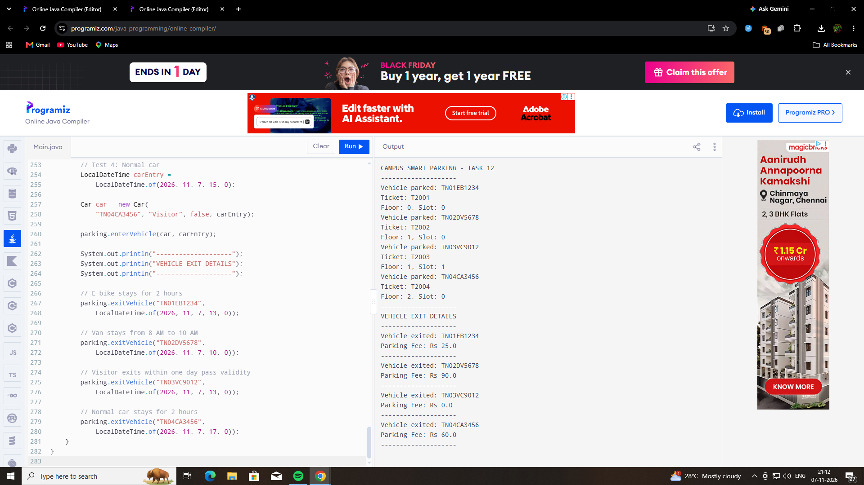

GITHUB LINK: https://github.com/192572027simats-del/CSA0922-JAVA-PROGRAMING/tree/main/ASSIGNMENTS

